# Software Test Documentation

# Introduction

The primary purpose of this chapter is to detect and prevent defects which may be created by developers while developing the software and this may lead to software failures. On the other hand, another objective of this chapter is to provide information about the level of quality and to make sure that the end result meets the business and user requirements. It contains the following sections:

* Test approach.
* Test stages.
* Test type.
* Test plan: Feature to be tested, Feature not to be tested, Test process, Test schedule, Testing tool and environment.
* Test cases.
* Checklist.
* Test report.

## Test approach

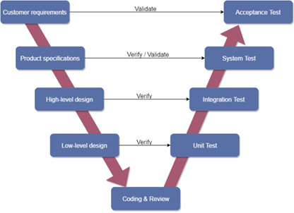

Overall, we choose V-Model to implement the testing process. With V-Model, software development is separated into two appropriate phase’s groups: development and testing. In this model, the verification and validation will be done side by side. It emphasizes the strict process flow to develop a quality product. The errors occurring in any phase will be corrected in that phase. Proactive defect tracking defects, which are found at early stages even, may be in the development phase before application being tested.

# Test stages

In this project, there are 3 phases in the testing process: Integration testing, System testing and Acceptance testing.

|  |  |  |
| --- | --- | --- |
| No. | Test Stages | Description |
| 1 | Integration testing | Integration testing allows individuals the opportunity to combine all of the units within a program and test them as a group. This testing level is designed to find interface defects between the modules/functions. This is particularly beneficial because it determines how efficiently the units are running together. |
| 2 | System testing | System testing is the first level in which the complete application is tested as a whole. The goal at this level is to evaluate whether the system has complied with all of the outlined requirements and to see that it meets Quality Standards. |
| 3 | Acceptance testing | Acceptance testing (or User Acceptance Testing), is conducted to determine whether the system is ready for release. During this phase, the tester and some alpha test users will test the system to find out whether the application meets their business’ needs. |

Table 5.1 – Testing stages

# Test type

The test team has to test the following type on Google Chrome browser:

* GUI test
* Function test
* Acceptance test
* Unit test

|  |  |  |  |
| --- | --- | --- | --- |
| **Type of test** | **Stage of test** | | |
| **Integration test** | **System test** | **Acceptance test** |
| Unit test | x | x |  |
| GUI test |  | x | x |
| Function test | x | x | x |
| Acceptance test |  | x | x |

Table 5.2 – Test type (or test stages)

# Test plan

## *Features to be tested*

|  |  |
| --- | --- |
| Actor | Feature |
| Candidate | View recruitment process |
| View home |
| View all jobs |
| View list jobs by region |
| View list jobs by unit |
| View job detail |
| Search job |
| Create CV |
| Upload CV |
| Register potential candidate |
| Edit CV |
| Take quiz |
| HR Staff | Login |
| Logout |
| View all CVs |
| View detail CV |
| Change CV status |
| Search CV |
| Delete CV |
| Send email quiz |
| Export CV |
| View all jobs |
| Add job |
| Edit job |
| Delete job |
| Search job in HR |
| View list CVs applied for a job |
| View all error emails |
| Resend all error email |
| Resend each error email |
| Super Admin | Login |
| Logout |
| View all accounts |
| Add account |
| Edit account |
| Delete account |
| View all units |
| Add unit |
| Edit unit |
| Delete unit |
| View all locations |
| Add location |
| Edit location |
| Delete location |
| View all question groups |
| Add question group |
| Edit question group |
| Delete question group |
| View all questions |
| Add question |
| Edit question |
| Delete question |
| Search question |
| View all quizzes |
| Add quiz |
| Edit quiz |
| Delete quiz |
| View all careers |
| Add career |
| Edit career |
| Delete career |
| View all config emails |
| Add config email |
| Edit config email |
| Delete config email |
| View logs |

## *Features not to be tested*

All features are listed in Section 1.6.3 will not to be tested.

## *Test process*

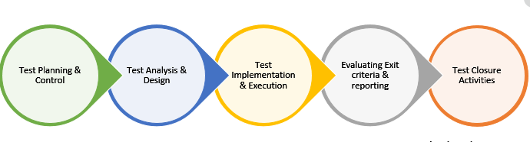

* Test Planning and Control use requirement specification test plans will make more detailed decisions about the overall approach of testing.
* Test Analysis and Design design and create test cases.
* Test Implementation and Execution: execute test procedures using test execution tools, check actual results with expected results.
* Evaluating exit criteria and Reporting defines when to stop testing based on time.
* Test closure activities update Test Report and if there is an error then report error.

## Test schedule

The table below describes the test schedule for the FERS Project:

|  |  |  |  |
| --- | --- | --- | --- |
| **Test Schedule** | **Start Date** | **End Date** | **Responsibilities** |
| Unit test | July 01, 2020 | August 26, 2020 | TuanDV |
| GUI test | July 05, 2020 | July 15, 2020 | LuyenDD |
| System test | July 25, 2020 | August 31, 2020 | LuyenDD, TuanDV |
| Acceptance test | July 30, 2020 | August 21, 2020 | FPT HR Staffs |

*Table 5.3 – Test schedule*

## Testing Tools and Environment

### ***1. Testing Tools***

* Chrome 84.0.4147.135 (64-bit) DevTools: To view logs, inspect elements.



* Microsoft Excel: To manage test cases
* Microsoft Visual Studio 17: To run unit tests and create/ update code unit tests.

### Testing Environment

|  |  |  |
| --- | --- | --- |
| Type of testing | Software | Hardware |
| System test & Acceptance test & Test case | * Google Sheet. * Google Docs. * Google Chrome 84.0.4147.135 (64-bit) | Personal computer for developing with the minimum configuration:  - Laptop Asus  - 2.20GHz Intel Core i7  - RAM: 16GB |
| Unit test | * Microsoft Visual Studio 2017 | Personal computer for run testing with minimum configuration:   * Laptop Asus rog gl552vx * Core i7 6700HQ 2.6GHz * RAM: 8GB |

*Table 5.4 – Testing Environment*

# Test cases

Test cases have been managed on the [Test Case Sheet](https://docs.google.com/spreadsheets/d/197FWUa32-QykdtH1zgmdGq5hVTbtytHeO_tPqkG9wMI/edit?pli=1#gid=1250043366). These are some example images about the Test cases below:

## 

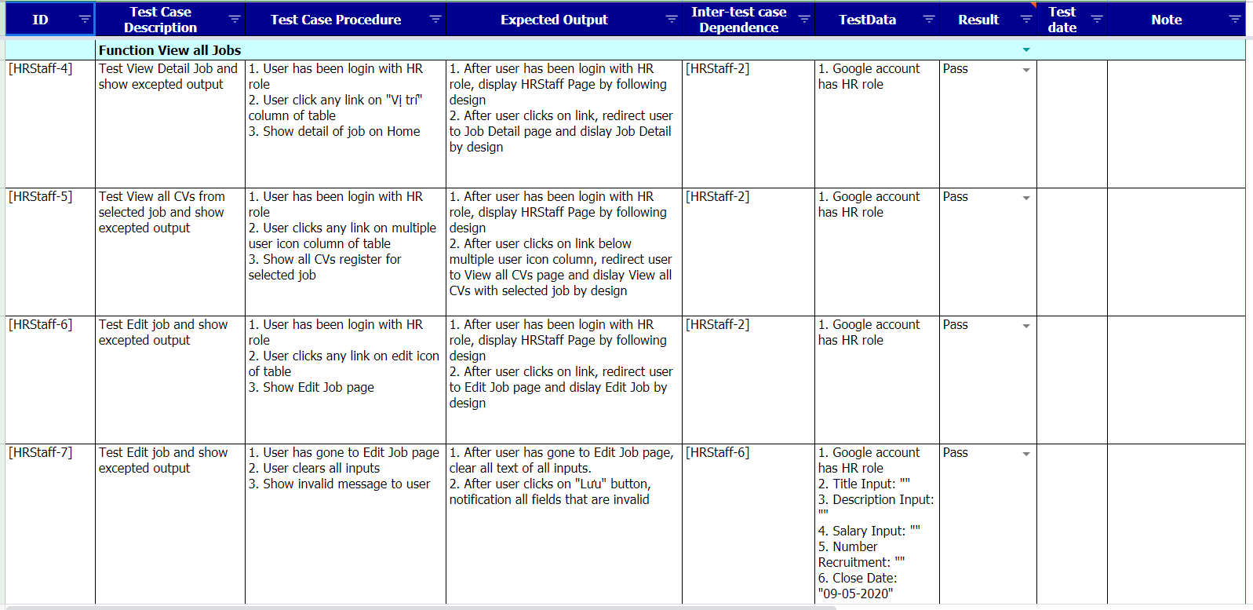

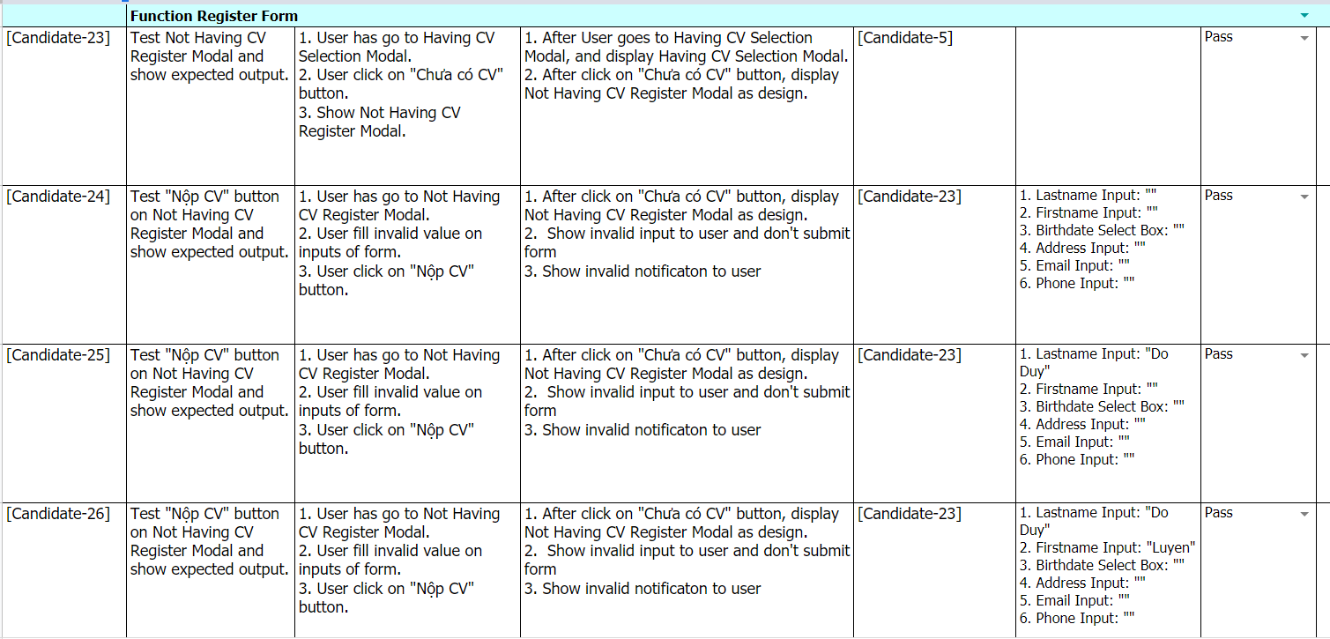

# Checklists

|  |  |  |  |
| --- | --- | --- | --- |
| ID | Checklists | Yes | No |
|  | General |  |  |
| CL-01 | Functionality of buttons available on all pages. | √ |  |
| CL-02 | Validation error messages are displayed properly below the field. | √ |  |
| CL-03 | All numeric values are formatted properly. | √ |  |
| CL-04 | All error messages are displayed using red color. | √ |  |
| CL-05 | Delete functionality for any record on the page is asked for confirmation. | √ |  |
| CL-06 | Text does not have grammatical and spelling errors. | √ |  |
| CL-07 | Application crash or unavailable pages are redirected to the error page. | √ |  |
| CL-08 | Navigation space is the same on all pages. | √ |  |
| CL-09 | Feature buttons on all page displays with the right role of users. | √ |  |
| CL-10 | All mandatory fields are validated and required. | √ |  |
| CL-11 | All messages create/update/delete successfully using blue color. | √ |  |
| CL-12 | All messages create/update/delete failure using red color. | √ |  |
|  | GUI and Usability |  |  |
| CL-13 | Information is presented in the order that the user needs it. | √ |  |
| CL-14 | All fields on page (e.g. text box, radio options, dropdown lists) should be aligned properly. | √ |  |
| CL-15 | The text is easy to understand. Don't use slang, acronyms, and abbreviations. | √ |  |
| CL-16 | Icons and images are designed to give impression and copyright. | √ |  |
| CL-17 | The most important fields are located where they are easy to see. | √ |  |
| CL-18 | Candidate’s screens have responsive for mobile, laptop, desktop devices | √ |  |
| CL-19 | Candidate’s screen has header and footer on every single screen. | √ |  |
| CL-20 | SuperAdmin/ HR Staff screen has menu on the left in each screen | √ |  |
| CL-21 | Only enable scroll when screen overheight or overwidth | √ |  |
| CL-22 | All image tags have an “alt” attribute to decorate an image when the image wasn't downloaded. | √ |  |
|  | Database |  |  |
| CL-23 | Values columns are not accepting null values. | √ |  |
| CL-24 | Input date of birth cannot be greater than current date. | √ |  |
| CL-25 | Null values are not allowed for Primary key columns. | √ |  |
| CL-26 | Radio button options are saved correctly in the database with true/false. | √ |  |
| CL-27 | Input data is not truncated. Field length shown to the user on page and in database schema should be the same. | √ |  |
| CL-28 | Input numeric fields with minimum, maximum, and float values. | √ |  |
| CL-29 | Input date is formatted dd/mm/yyyy | √ |  |
| CL-30 | Database fields are designed with correct data type and data length. | √ |  |
| CL-31 | Input field leading and trailing spaces are truncated before committing data to the database. | √ |  |
| CL-32 | Fields of columns are unique then cannot duplicate. | √ |  |
|  | Security |  |  |
| CL-33 | Test login with google authenticator. | √ |  |
| CL-34 | Do not save all information of the account logged, but only save uuid in session. | √ |  |

*Table 5.5 – Checklist*

# Test Report

* Acceptance test has been manage on the [Acceptance test sheet](https://docs.google.com/spreadsheets/d/1sIGlyMv5f2mLmO9ZZm__muP2ZmpWPnH41FqGgFeifEA/edit?usp=sharing)
* Test report has been manage on the [Test report sheet](https://docs.google.com/spreadsheets/d/197FWUa32-QykdtH1zgmdGq5hVTbtytHeO_tPqkG9wMI/edit#gid=1395313998)